DATA SCIENCE & MACHINE LEARNING
LAB CYCLE 2

- Create a three dimensional array specifying float data type and print it.

Code:
import numpy as np
a = np.array([[[1,2],[3,4]],[[5,6],[7,8]],[[1,1],[2,2]]],dtype=float)
print(a)
Output:
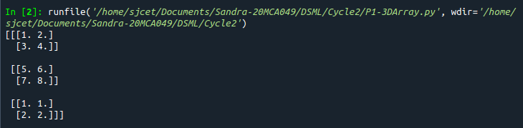

- Create a 2 dimensional array (2X3) with elements belonging to complex data type and print it. Also display
- the no: of rows and columns
- dimension of an array
- reshape the same array to 3X2
Code:
import numpy as np
x = np.array([[2, 4, 6], [6, 8, 10]], dtype = complex )
print("original Array")
print(x)
print("No.of rows and columns=",x.shape)
print( "Dimension=" ,x.ndim)
newarr = x.reshape(3,2)
print(" Reshaped Array ")
print(newarr)
Output:
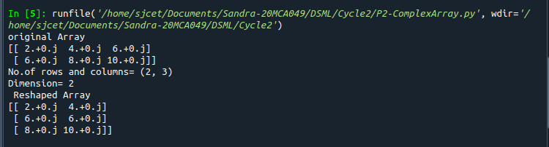

- Familiarize with the functions to create
- an uninitialized array
- array with all elements as 1,
- all elements as 0
Code:
import numpy as np
print("Uninitialized Array:")
x=np.empty([2, 2])
print(x)
print("Array with all elements as 1:")
y=np.full((2, 2), 1)
print(y)
print("Array with all elements as 0:")
z=np.full((2, 2), 0)
print(z)
Output:
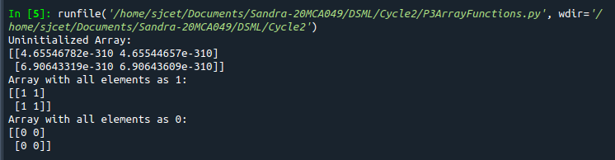

- Create an one dimensional array using arange function containing 10 elements.
Display
- First 4 elements
- Last 6 elements
- Elements from index 2 to 7
Code:
import numpy as np
print("Array:")
a = np.arange(1, 11, 1)
print(a)
print("First 4 elements:")
e = a[:4]
print(e)
print("Last 6 Elements:")
e1 = a[4:]
print(e1)
print("Elements from index 2 to 7:")
e2 = a[1:7]
print(e2)
Output:
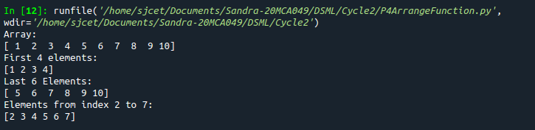

- Create an 1D array with arange containing first 15 even numbers as elements
- Elements from index 2 to 8 with step 2(also demonstrate the same using slice function)
- Last 3 elements of the array using negative index
- Alternate elements of the array
- Display the last 3 alternate elements
- Display the elements from indices 4 to 10 in descending order(use –values)
Code:
import numpy as np
array_1d=np.arange(0,30,2)
print("first 15 even numbers as elements:")
print(array_1d)
print("Elements from index 2 to 8 with step 2:")
print(array_1d[2:9:2])
print("Elements from index 2 to 8 using slice function:")
print(a[slice(2, 9, 2)])
print("Last 3 elements of the array using negative index:")
print(array_1d[-3:-1])
print("Alternate elements of the array:")
print(array_1d[::2])
print("Display the last 3 alternate elements:")
print(array_1d[-3:-1:2])
print("Display the elements from indices 4 to 10 in descending order")
print(array_1d[10:4:-1])
Output:
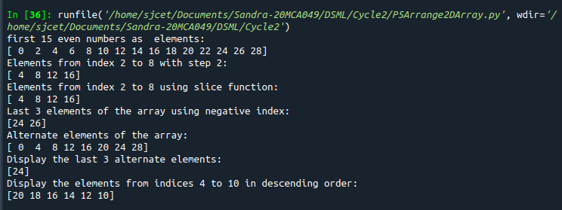

- Create a 2 Dimensional array with 4 rows and 4 columns.
- Display all elements excluding the first row
- Display all elements excluding the last column
- Display the elements of 1st and 2nd column in 2nd and 3rd row
- Display the elements of 2nd and 3rd column
- Display 2nd and 3rd element of 1st row

Code:
import numpy as np

array_2d=np.array([[1,2,3,4],[5,6,7,8],[9,10,11,12], [13,14,15,16]])
print(array_2d)
print("Display all elements excluding the first row")
print(array_2d[1:4,:])
print("Display all elements excluding the last column")
print(array_2d[:,0:3])
print("Display the elements of 1 st and 2 nd column in 2 nd and 3 rd row")
print(array_2d[1:3,0:2])
print("Display the elements of 2 nd and 3 rd column")
print(array_2d[:,1:3])
print("Display 2 nd and 3 rd element of 1 st row")
print(array_2d[0,1:3])

Output:

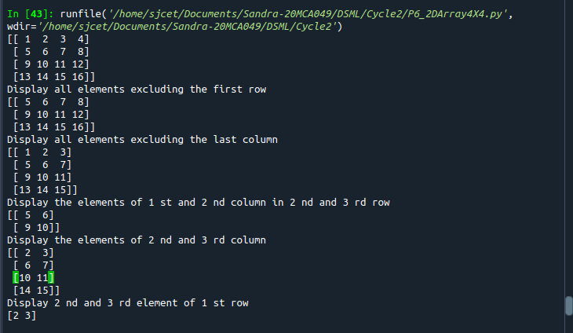

- Create two 2D arrays using array object and
- Add the 2 matrices and print it
- Subtract 2 matrices
- Multiply the individual elements of matrix
- Divide the elements of the matrices
- Perform matrix multiplication
- Display transpose of the matrix
- Sum of diagonal elements of a matrix
Code:
import numpy as np
M1 = np.array([[9, 4], [5, 12]])
print("First Array:")
print(M1)
M2 = np.array([[3, 6], [2, 8]])
print("Second Array:")
print(M2)
M3 = M1 + M2
print("Matrix addition")
print(M3)

M3 = M1 - M2
print("Matrix Substract")
print(M3)

M3 = M1 / M2
print("Divide the elements of the matrices")
print(M3)

M3 = M1 * M2
print("Multiply the individual elements of matrix")
print(M3)

M3 = M1.dot(M2)
print("matrix multiplication")
print(M3)

M2 = M1.transpose()
print("Transpose of the matrix")
print(M2)

print("Sum of diagonal elements of a matrix")
print(np.trace(M1))

Output:
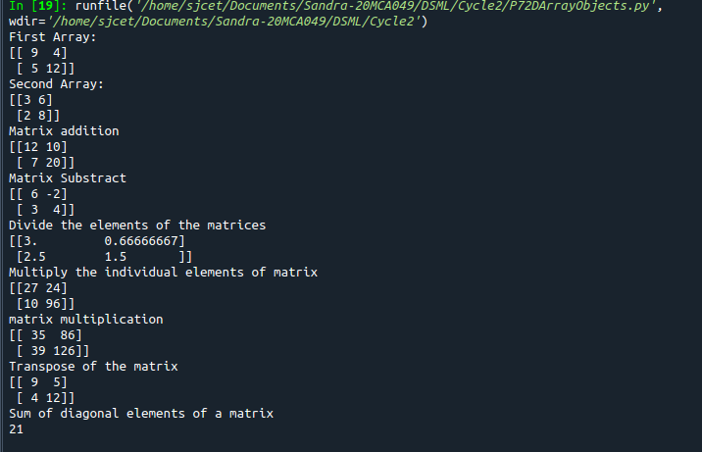
- Demonstrate the use of insert() function in 1D and 2D array
Code:

import numpy as np

arr1 = np.arange(5)
print("1D ARRAY \n")
print("The array is: \n", arr1)
obj = 2
value = 10
arr = np.insert(arr1, obj, value, axis=None)

print("\nAfter inserting the new array is: ")
print(arr)
print("\nShape of the new array is : ", np.shape(arr))

print("\n2D ARRAY ")

arr1 = np.array([(1, 2, 3), (4, 5, 6), (7, 8, 9), (50, 51, 52)])
print("\nThe array is: ")
print(arr1)
print("\nThe shape of the array is: ", np.shape(arr1))
a = np.insert(arr1, 1, [[50], [100], ], axis=0)
print("\nNew array is : ")
print(a)
print("\nShape of the array is: ", np.shape(a))
Output:

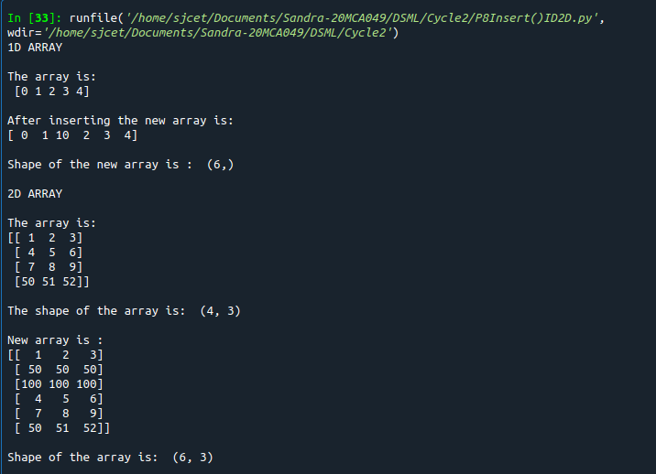

- Demonstrate the use of diag() function in 1D and 2D array.
Code:
import numpy as np
print("1D Array:")
ar = np.arange(1,6).reshape(1,5)
print(ar)
print("\nDiagonal Array Is:")
print(np.diag(ar))
print("\n 2D Array:")
a = np.arange(9).reshape((3,3))
print(a)
print("\nDiagonal Array Is:")
print(np.diag(a))
Output:

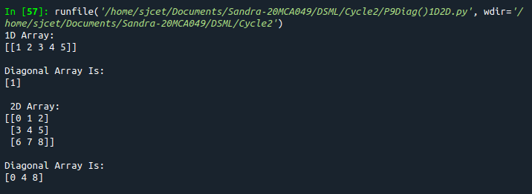
- Demonstarte the use of append() function in 1D and 2D
array.
Code:

import numpy as np
ar = np.array([1, 2, 3, 4, 5, 6, 7])
a = np.append(ar,6)
print("1D array",ar)
print("the use of append() function in 1D array \n",a)
ar1 = np.array( [ [1, 2, 3],[ 4, 5, 6] ])
print("2D array : \n", ar1)

a = np.append(ar1,np.array([[7,8,9]]),axis=0)
print("\n2D array")
print(ar1)
print("the use of append() function in 2D array")
print(a)

Output:
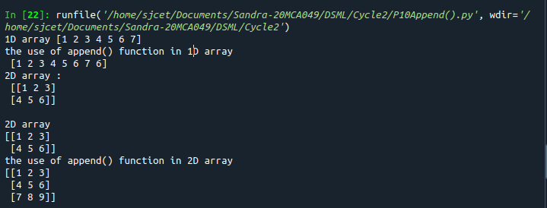

- Demonstarte the use of sum() function in 1D and 2D array.

Code:

import numpy as np
a = np.arange(5)

print("1D ARRAY \n")
print("The array is: \n", a)

print("\nSum of array : ", np.sum(a))

print("\n2D ARRAY ")
ar = np.array([(1, 2, 3), (4, 5, 6), (7, 8, 9)])

print("\nThe array is: ")
print(ar)

print("\nSum of array : ", np.sum(ar))

Output:
